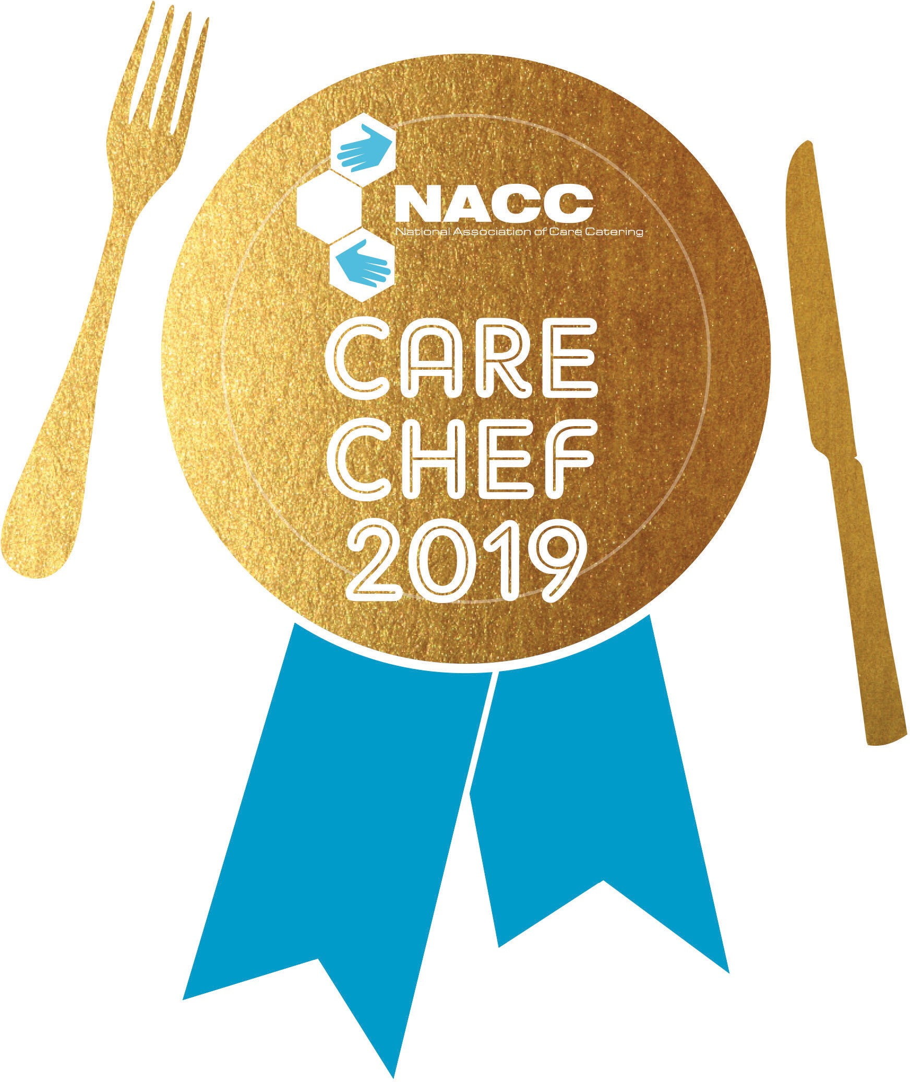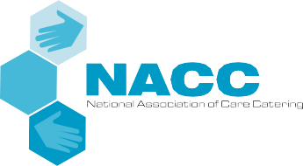

PAGE 1

Please complete the entry form fully as these details will be used to make contact with you

NACC Nominating Member

Non-member

Entrants Name

Workplace Address

Postcode

Telephone

Email

NACC Region

SOUTH EAST

SOUTH WEST

MIDLANDS

NORTH

WALES

SCOTLAND

Establishment Name

Local Authority/Organisation

Who handles, if anyone, the publicity for your organisation in the event that you are shortlisted as a ﬁnalist?

Client group the recipes are suitable for

Recipe Name

SPONSORS & SUPPORTERS

Non-members please attach your entry fee of £67+VAT

Please make cheques payable to The National Association of Care Catering

Please return your completed submission to:

NACC Administration Oﬃce, Meadow Court, Faygate Lane, Faygate, West Sussex RH12 4SJ

**Tel:** 0870 748 0180 **Fax:** 0870 748 0181 **Email:** [info@thenacc.co.uk](mailto:info@thenacc.co.uk)

The Worshipful Company of Cooks



PAGE 2

Please complete the entry form fully as these details will be used to make contact with you

**MAIN COURSE METHOD – Please bullet point and number each step?**

**INGREDIENT QUANTITY/AMOUNT**

**INGREDIENT**

**AMOUNT**

**COST**

**SUPPLIER**

Total cost for three portions:

Premier Foods product from list:

**MAIN COURSE**



PAGE 3

Please complete the entry form fully as these details will be used to make contact with you

**DESSERT METHOD – Please bullet point and number each step?**

**INGREDIENT QUANTITY/AMOUNT**

**INGREDIENT**

**AMOUNT**

**COST**

**SUPPLIER**

Total cost for three portions:

Premier Foods product from list:

**DESSERT**

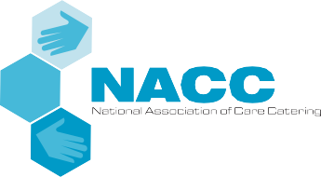

***Please feel free to use separate sheets as necessary.***

PAGE 4

Please complete the entry form fully as these details will be used to make contact with you

SPONSORS & SUPPORTERS

Non-members please attach your entry fee of £67+VAT

Please make cheques payable to The National Association of Care Catering

Please return your completed submission to:

NACC Administration Oﬃce, Meadow Court, Faygate Lane, Faygate, West Sussex RH12 4SJ

**Tel:** 0870 748 0180 **Fax:** 0870 748 0181 **Email:** [info@thenacc.co.uk](mailto:info@thenacc.co.uk)

The entry form is available in electronic form via the NACC Care Chef 2019 promoters

NACC, Admin Oﬃce, Meadow Court, Faygate Lane, Faygate, West Sussex, RH12 4SJ

**Tel:** 0870 748 0180 **Fax:** 0870 748 0181 **Email:** [info@thenacc.co.uk](mailto:info@thenacc.co.uk)

The Worshipful Company of Cooks

Main nutritional problems experienced by your residents and how this menu will help to address these