Press Release 23/09/2024
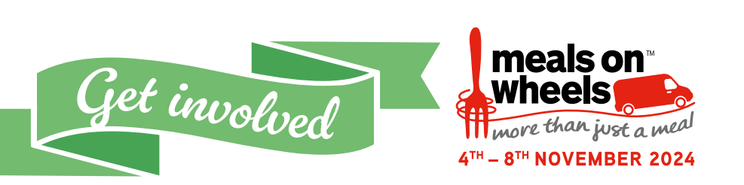
Get Involved – Meals on Wheels Needs our Support

Meals on Wheels Week returns 4th November to 8th November 2024. The award-winning national event, organised by the National Association of Care Catering (NACC), raises awareness of and celebrates Meals on Wheels services across the country and the vital role they play in supporting older and vulnerable people living in our communities.
It is an initiative that brings together Health and Social Care sector, caterers, service providers, food suppliers, volunteers, carers, older people and public to raise awareness about the importance of meals delivered in the community – whether via Meals on Wheels services, day centres or lunch clubs for older people and those with vulnerabilities
Each day throughout the week there are activities planned to highlight some of the particular elements of Meals on Wheels:

Monday 4th November - Multi-Cultural Monday
The UK has a multi-cultural demographic for older and vulnerable people requiring the service. Multi-Cultural Monday is about recognising the diversity of the meals on wheels service, and how it connects and offers meals to cater for all.

Tuesday 5th November - Thank you Tuesday
Show your appreciation for everyone that contributes to Meals on Wheels services, whether that’s the team members making the meals, volunteers, drivers, carers, or those that work behind the scenes, today is the day to show our gratitude.

Wednesday 6th November - VIP on Wheels
There’s no better way to convey the value of our services, than seeing it in action and the impact it has on service users. VIP on Wheels is a fantastic opportunity to invite local MPs, VIPs and dignitaries to experience service delivery and celebrate your service and the immense value it adds to the lives of those receiving it.

Thursday 7th November - Connect Thursday
Not all vulnerable and older people have the luxury of leaving their homes, due to a host of reasons. Meals on Wheels is more than just a meal, and offers these individuals connection with people, an opportunity for wellbeing checks and in some cases a smile and chat in person with another human. Join us in sharing your examples on how you connect with your service users.

Friday 8th November - Friday Friends
Highlight the importance of social eating and how it helps reduce loneliness and social isolation. Friday Friends will bring people in our communities together to share the joy of food and time. This could be at a lunch club, day centre, or a care home could invite the local community in for afternoon tea. And where this may not be possible, why not simply invite a neighbour for lunch? This small gesture is sure to have an immense impact

The week is also an ideal opportunity to spotlight the social contribution of Meals on Wheels services. Loneliness and social isolation are prevalent on our communities and Meals on Wheels, together with lunch clubs and day centres, play a critical role in reducing this.
Neel Radia, National Chair of the National Association of Care Catering and Lead for Meals on Wheels Week said, “Last year we released a report in partnership with Association for Public Service Excellence (APSE), that showed vital Meals on Wheels services on the brink of collapse, with only 29% still in operation across the UK operated by Local Authorities, and fewer than 18% in England. Anecdotally, this situation has not improved.
Since the NACC started this campaign over 30 years ago, Meals on Wheels Week remains relevant. We are asking the public to support local meal services that helps address loneliness, social isolation, and safety in the community for older and vulnerable people.”

To find out more please visit: thenacc.co.uk/events/meals-on-wheels-week-2024

- Ends –

Notes to editors:

For further information contact: Craig Smith at press@thenacc.co.uk / 07774 759 558.
Meals on Wheels – more than just a meal
The NACC is a longstanding campaigner of Meals on Wheels. As well as nutritious food, it offers friendly human interaction and wellbeing checks – vital ingredients that allow the vulnerable to live independently in their own homes. It keeps them nourished and hydrated with a nutritious daily meal (in many cases the only one they will have each day) and provides an essential preventative service that reduces costly malnutrition-related admissions to hospital that are adding to the terrible strain on the NHS. For many service users, Meals on Wheels is so much more than just a meal. It’s a social lifeline that eases the devastating effects of isolation and loneliness. The delivery of a meal brings regular human contact, which for many may be the only interaction they enjoy. It also provides much-needed wellbeing and safety checks, again, crucial for those that may not see anyone else during the day.

#MealsonWheels2024
#MoreThanJustAMeal
#SaveMealsOnWheels
www.thenacc.co.uk/events/meals-on-wheels-week-2024

Meals on Wheels Week is an initiative that brings together Health and Social Care sector, caterers, service providers, food suppliers, volunteers, carers, older people and public to raise awareness about the importance of meals delivered in the community – whether via Meals on Wheels services, day centres or lunch clubs for older people and those with vulnerabilities
The NACC
The National Association of Care Catering (NACC) unites, supports and represents everyone working in and associated with catering in the UK care sector. It is recognised as a respected source of information and opinion for the dynamic and growing area of care catering.
For more than 30 years, it has been committed to raising standards of care catering and championing the positive impact nutrition, hydration and mealtimes have on the physical and emotional health and wellbeing of older and vulnerable people in care settings.
www.thenacc.co.uk
If you would like to unsubscribe to our media list, please contact press@thenacc.co.uk

